Discord Assistant Bot

Jeonghoon Yoo
Dept. of Computer Science
Vanderbilt University
Nashville, TN
jeonghoon.yoo@vanderbilt.edu
Alan Yang
Dept. of Computer Science
Vanderbilt University
Nashville, TN
alan.s.yang@vanderbilt.edu
Yigit Duzenlioglu
Dept. of Computer Science
Vanderbilt University
Nashville, TN
yigit.duzenlioglu@vanderbilt.edu

Abstract—Computer science students often encounter challenges in consolidating their academic tools and navigating the diverse range of available resources, particularly for those less familiar with these tools. Discord's widespread adoption among computer science students presents an opportunity to address these challenges effectively. This project introduces a Discord bot designed to support computer science students by centralizing optimal search results and offering a suite of tools to enhance their academic pursuits. The bot can seamlessly integrate into any Discord server, aiding students. Leveraging APIs from Reddit, Stack Overflow, Booksrun, and Google Books, the bot aggregates programming-related search results, retrieves textbook prices, and facilitates Pomodoro study sessions. Utilizing cloud technologies such as Chameleon Virtual Machine and Docker ensures continuous availability of the bot, enhancing productivity and academic success.

Introduction
Computer science students often face challenges in centralizing their academic tools and navigating the multitude of available options, particularly those who may be less familiar with them. Discord has emerged as a popular communication platform among computer science students, offering a collaborative environment for discussions and information sharing. Leveraging Discord's popularity and functionality, this project aims to develop a Discord bot specifically tailored to address the unique needs of computer science students.
This paper presents the design and development of the Discord Assistant Bot, highlighting its key features and potential impact on enhancing the academic journey of computer science students.

Solution

Functionalities
This project aims to support computer science students by centralizing the best search results and providing various tools to assist them in their studies. The Discord bot can be seamlessly added to any server, aiding individuals or groups of students in their academic endeavors. Its strength lies in its versatility and accessibility.

Our Discord bot leverages Reddit and Stack Overflow APIs to aggregate programming-related search results and fetches textbook prices from Booksrun and Google Books to offer the best options for textbook price and rental. Additionally, students can use Pomodoro study timers to enhance their study sessions, with the bot providing timely notifications when necessary.

Cloud Technologies
Cloud technologies play a crucial role in ensuring the reliability and availability of the Discord bot. By deploying the bot on a Chameleon Virtual Machine with Docker containers, continuous uptime is guaranteed, allowing students to access the bot's functionalities all the time. Furthermore, the bot leverages REST APIs from platforms like Reddit, Stack Overflow, Booksrun, and Google Books to retrieve and aggregate data in a user-friendly format.

Architecture
The Discord Assistant Bot architecture (Figure 1) encompasses several key components to facilitate seamless interaction between users and the bot. Users interface with the bot through the Discord client, whether it be via application or browser, where they can issue commands and receive responses. The bot communicates with Discord servers and users via the Discord API, listening for commands and events in designated channels that contains the Discord bot. Its core logic and functionality reside within the bot application, which is deployed on cloud infrastructure, specifically a Chameleon Virtual Machine using Docker containers. This setup ensures continuous availability and scalability of the bot when necessary. When receiving requests from users, the backend of the bot interacts with external APIs, such as the Stack Exchange API for Stack Overflow data, Reddit API for Reddit posts, and Booksrun and Google Books APIs for textbook prices. Data retrieved from these APIs undergoes processing within the bot application, including filtering, sorting, and formatting, before being presented to users. The backend contains error handling mechanisms and logging functionality for monitoring and debugging purposes.
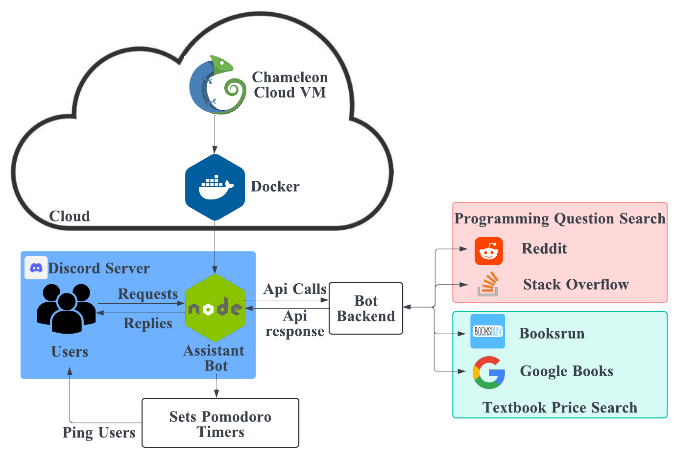
- Discord Assistant Bot architecture

User Interface
User interactions with the bot are facilitated through commands prefixed with the designated slash (/) symbol. This presents the users with all the available functionalities of the bot that they can invoke (Figure 2). The programming related question search, denoted as /psearch, displays the best results from the aggregated results from our search algorithm in an organized format that highlights titles and links (Figure 3). Similarly, the textbook search function, denoted as /booksearch, presents our recommendation for the best options for new, used, and rental books (Figure 4). A notification system is integrated for sending timely reminders and updates to users regarding the progress of study sessions, breaks, and study cycles for the Pomodoro function (Figure 5).
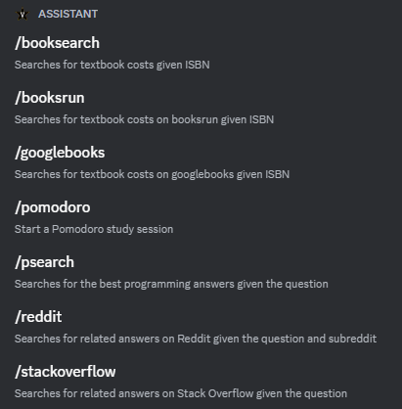
- List of slash (/) commands
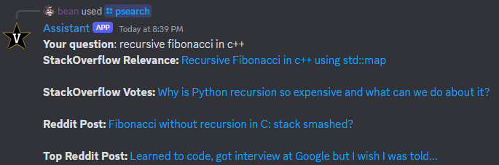
- Programming search reply
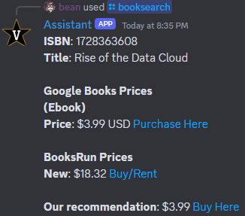
- Book search reply

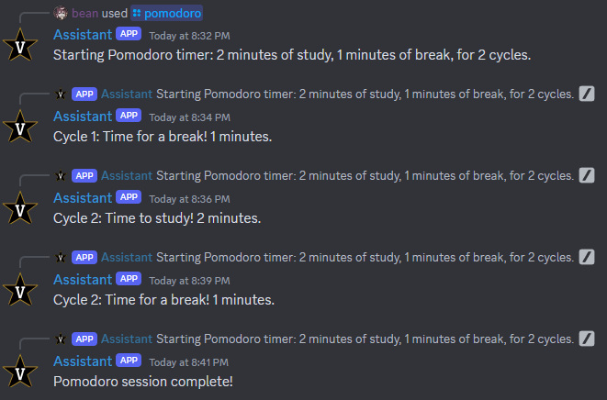

- Pomodoro timer feedback

Future Work
In our vision for the future of the Discord Assistant Bot, we aspire to create an indispensable resource for students. Our roadmap includes key features such as study group creation, scheduling assistance, task management, and class notes storage. These functionalities aim to streamline academic workflows and foster a community and collaborative work environment for students.
The bot will enable students to effortlessly create and manage study groups, facilitating study collaboration and meaningful discussions. Additionally, it will act as a reliable scheduler, helping students organize their academic and personal commitments efficiently. A comprehensive task management system will allow students to prioritize tasks and track progress. The class notes storage ensures easy access to essential study materials that students can utilize to study or share with others using the Discord bot.
Looking ahead, we are excited about the endless possibilities for further development. Our goal is to evolve our Discord bot into an indispensable tool that streamlines students' academic journeys and fosters collaborative learning.

Acknowledgment
The authors thank Dr. Vikash Singh for his valuable guidance and support during the development of this project. We are also grateful to Vanderbilt University and the School of Engineering for providing us with this invaluable opportunity.

